CRUISE REPORT
Cruise Number: NW15-01 Leg 2A

Ship:
Charter vessel Northwest Explorer
Area of Operations:
Western Gulf of Alaska. Data from NW15-01 Leg 2A (formerly NWE15-01 Leg 2A) in conjunction with DY15-07 completes Eco-FOCI survey coverage of the western Gulf of Alaska.
Itinerary:
Date depart / port: August 5, 2015 / Juneau, AK
Date arrive / port: August 25, 2015 / Juneau, AK
Participating organizations:
NOAA - Alaska Fisheries Science Center (AFSC)
Ecosystems & Fisheries-Oceanography Coordinated Investigations (Eco-FOCI)
Ecosystem Monitoring and Assessment (EMA)
NOAA – Pacific Marine Environmental Laboratory (PMEL)

Chief Scientist:
Matt Wilson M / AFSC / Eco-FOCI
Personnel:
Morgan Busby M / AFSC / Eco-FOCI
Benny Eckerson M / AFSC / PMEL
Wesley Strasburger M / AFSC / EMA
Cruise Objectives:
Conduct a fisheries (midwater trawl) and oceanographic survey to:
- Extend time series of age-0 Walleye Pollock abundance in the western Gulf of Alaska;
- Describe the community structure, biomass, energetic status of pelagic nekton;
- Collect age-0 Walleye Pollock associated prey and measure environmental variables that potentially affect Walleye Pollock ecology;
- Conduct rapid assessment of zooplankton composition and abundance (C. Harpold);
- Collect juvenile gadids for a rapid-assessment diet study (N. Ferm, J. Duffy-Anderson); and
- Collect surface salinity samples and profiler data for post-cruise ground-truth of profiler data.

Gear used (number of tows/casts):
20BON - 20cm bongo (n = 67)
60BON - 60cm bongo (n = 67)
ANCHO - Anchovy trawl (n = 71)
Furuno attached to net (n = 71)
CAT - Seabird SeaCAT CTD (n = 74)

Samples/data collected:
SeaBird SeaCat CTD (72 successful casts)
Surface (bucket) salinity samples (7 bottles, #73-79)
Quantitative zooplankton tow preserved in formalin (203 gear-net-tows, 260 jars)
zooplankton rough counts for Colleen Harpold (8 sites assessed, 520 animals counted)

Fish body lengths measured:
RACEbase Species - Common Name = At-sea entry name | No. fish
arrowtooth flounder | 1
capelin | 257
eulachon | 889
Pacific cod, age-0 | 88
Pacific cod, age-0 (deformed, do NOT use body length) | 1
Pacific herring | 21
Pacific ocean perch, adult | 1
sablefish | 1
salmon, chum | 5
salmon, coho | 1
salmon, pink | 1
salmon, sockeye | 1
walleye pollock, age-0 | 127
walleye pollock, age-1 | 4
walleye pollock, age-1+ | 591
walleye pollock, age-2+ | 122
Grand Total | 2111

Animals preserved (mostly frozen)
At-sea entry name | No.
Rockfishes  Age-0 nonPOP or POP type | 7
Age-0 nonPOP type | 126
Age-0 nonPOP type A | 93
Age-0 nonPOP type B | 52
Age-0 POP type | 948
Flatfishes
flatfish larvae | 209
flathead sole larvae | 3
rex sole larva | 98
Salmon  salmon, chinook | 1
salmon, coho | 5
Gadids
Pacific cod, age-0 | 86
walleye pollock, age-0 | 122
walleye pollock, age-1 | 3
walleye pollock, age-1+ | 6
Miscellaneous  blob sculpin larva | 15
Chrysaora melanaster | 1
Aurelia aurita | 4
snailfish larva | 1
squid | 10
Grand Total | 1790

Summary of Operations:
The primary objective of the cruise was to conduct a trawl survey for age-0 Walleye Pollock and a bongo survey to collect age-0 Walleye Pollock associated prey from Kodiak Island to Blying Sound.

Summary of Cruise
The Northwest Explorer departed Juneau, AK on August 5, 2015, and arrived at site “gx187” at 0900 on 8 August. Along the grid of sites, sampling progressed northeastward out of Shelikof Strait, around the eastern end of Kodiak Island, southwestward to station “hl173” before sampling northeastward to Blying Sound where our last station (“hh221”) was completed at 1800 on 23 August (Figure 1). We returned Juneau on 25 August. Near our last station (station 71), a large “swarm” of moon jellyfish (Aurelia aurita) was photographed, samples collected, and temperature and salinity profiles measured; the site is indicated as station 70 on Figure 1. The main difference in sampling between this cruise and DY15-07, besides geographic area, was that operations on NW15-01 Leg 2A were conducted only during daylight (0600-1900 ADT).

Sampling at each site was the same as described in the DY15-07 Cruise Report (see Table 1 for sampling details): “a bongo tow was conducted first to collect zooplankton followed by a Stauffer (aka anchovy) trawl to sample age-0 Walleye Pollock and other forage fishes. The gear for zooplankton sampling was a 60-cm bongo frame with 0.505-mm mesh netting paired with a 20-cm bongo with 0.153-mm mesh.” A SeaCat (SBE-19+) was “mounted above the bongo to provide depth, temperature, and salinity data. Bongo tows were to 200 meters depth or 10 meters off the bottom where water depth was shallower. For each bongo array, Net 1 was preserved in” 5% formalin, and buffered with sodium borate (2% of total volume). “At selected stations, zooplankton from Net 2 from both arrays were sorted and counted and then discarded.”

“The Stauffer trawl was deployed to a depth of 200 meters, or 10 meters off the bottom, whichever was shallowest. A SBE-39 was deployed on the headrope as a backup depth sensor, and data were saved.” A Simrad sounder (model #FS900) was attached to the headrope center and transmitted echo sweeps and depth information via a third wire. “Standard trawl operations were used for deployment. The trawl was fished over a double-oblique path.”

“Walleye pollock (all age classes), Pacific cod, rockfishes, sablefish, capelin, eulachon, and flatfishes were sorted from the catch. Flatfishes were sorted to species if possible. Standard length (SL) was the body-length metric for age-0 Walleye Pollock. Fork length (FL) was the body-length metric for age-1+ Walleye Pollock. The following groups were frozen for subsequent examination in the laboratory: age-0 Walleye Pollock, age-1 Walleye Pollock, age-0 Pacific Cod, age-0 rockfish, and flatfish species (flatfish <100 mm TL).” Rockfishes were flash frozen in the –80ºC freezer. All other frozen specimens were kept in a standard chest freezer.

Days Lost to Weather:
No days were lost to weather. However, high seas slowed operations during storms and prevented plankton sampling at two stations (48 and 50); nevertheless, on average, 4.4 sites were sampled daily.
Days Lost to Equipment Failure:
0
Recommendations:
None
Acknowledgments:
The scientific party would like to acknowledge the hard work and support of Captain Ray Haddon and crew of the Northwest Explorer.

Attachments:

Figure 1. Sampling locations indicated by station number, which reflects chronological order of occupation.

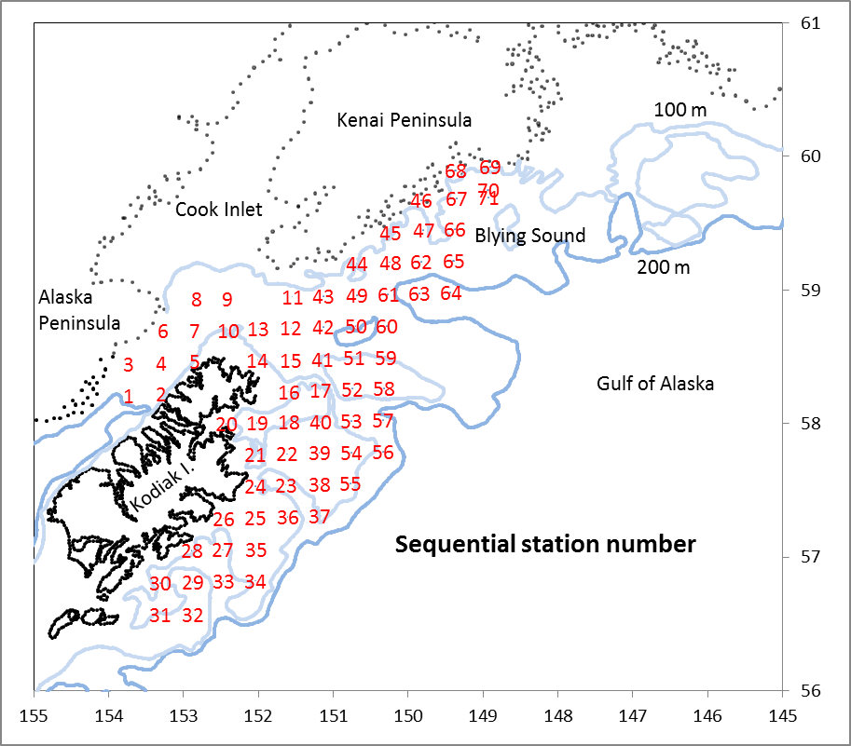

Table 1. NW15-01 cruise summary. Double click on table below for the complete cruise summary (embedded .pdf file).

